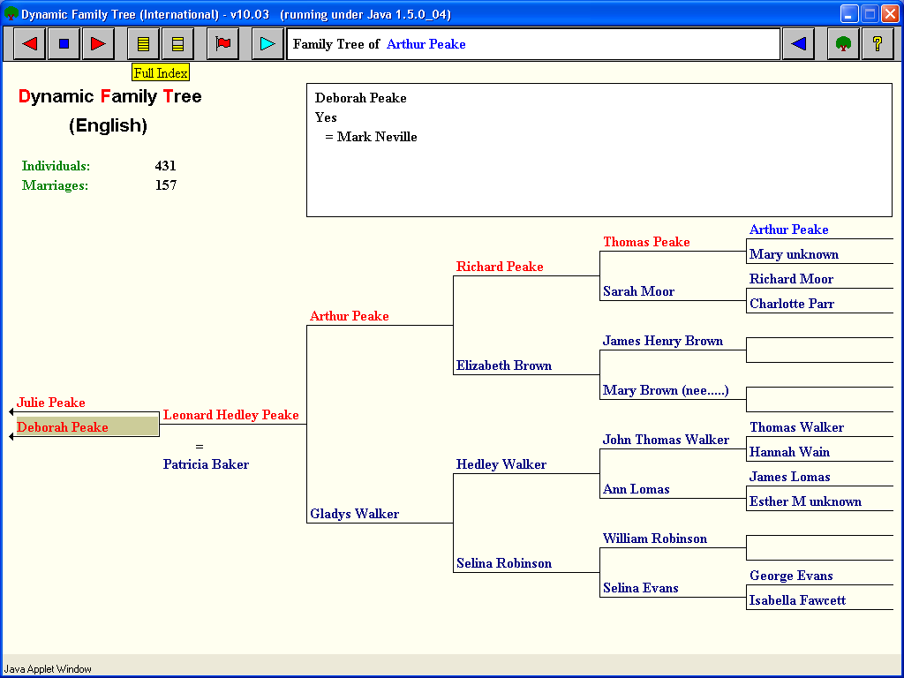
New to Dynamic Family Tree – here’s what to do:
Search through the “Full Index” in the pull down menu (Yellow Icon on the menu bar)

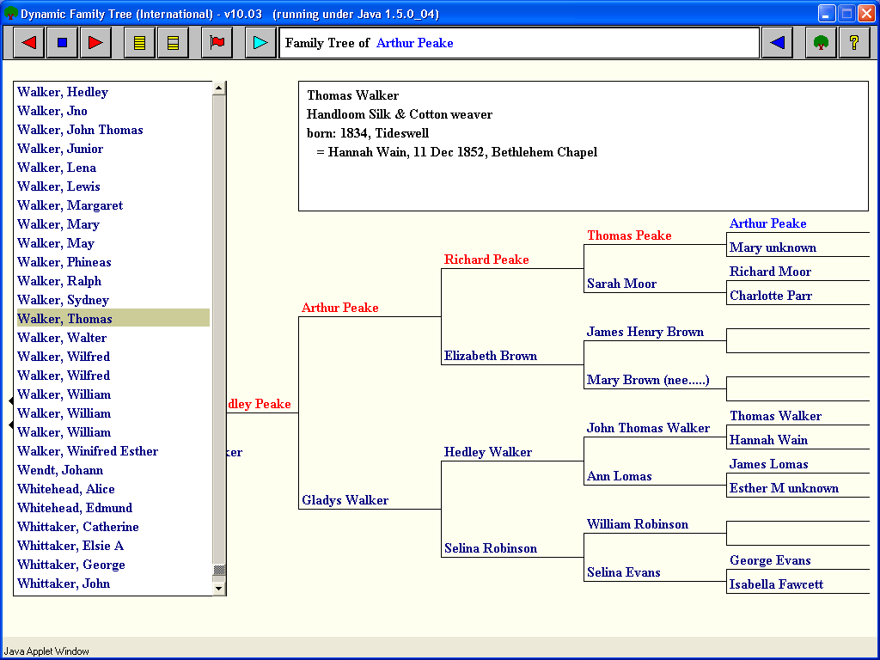
Hover the mouse over any person and their details are shown in information box at the top of the screen.
Click on the name to bring this person into the main tree area.
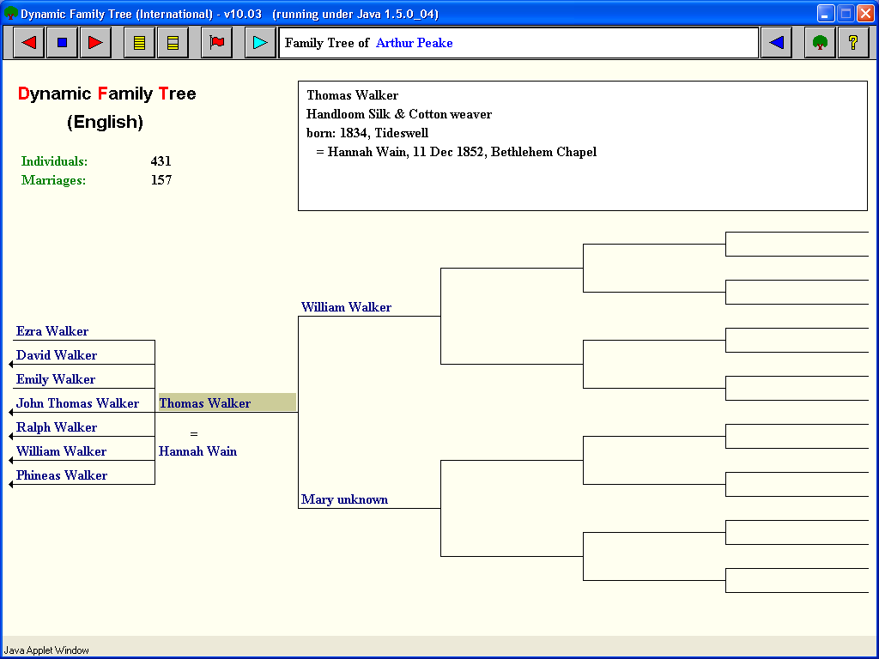

If a person on the far left has descendants, this is represented by an arrow. E.G. John Thomas Walker.
Click on this person to descend the tree.

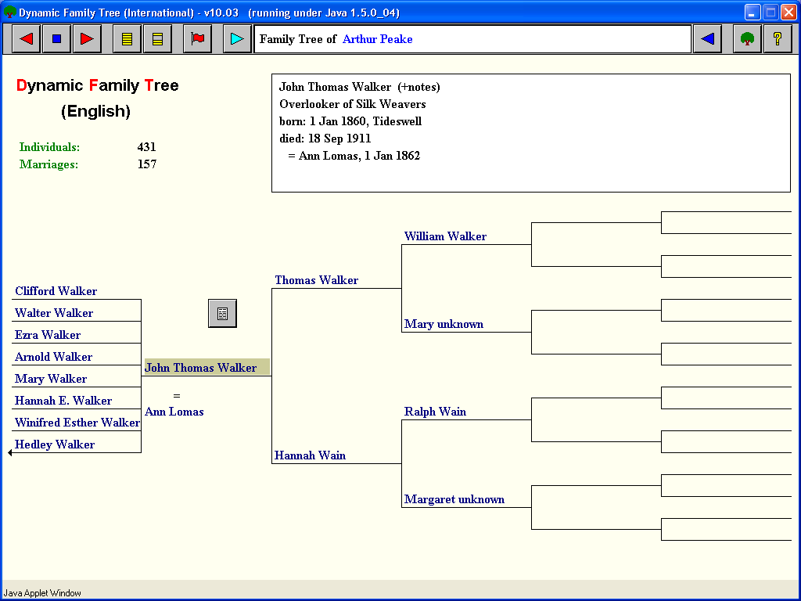

Click again on another arrow to continue descending. E.G. Hedley Walker

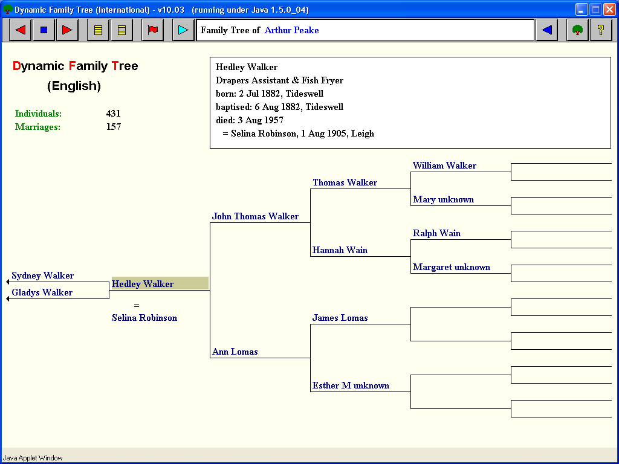
You can make the highlighted person the object of the family tree (Owner), by pressing the light blue triangle on the menu bar

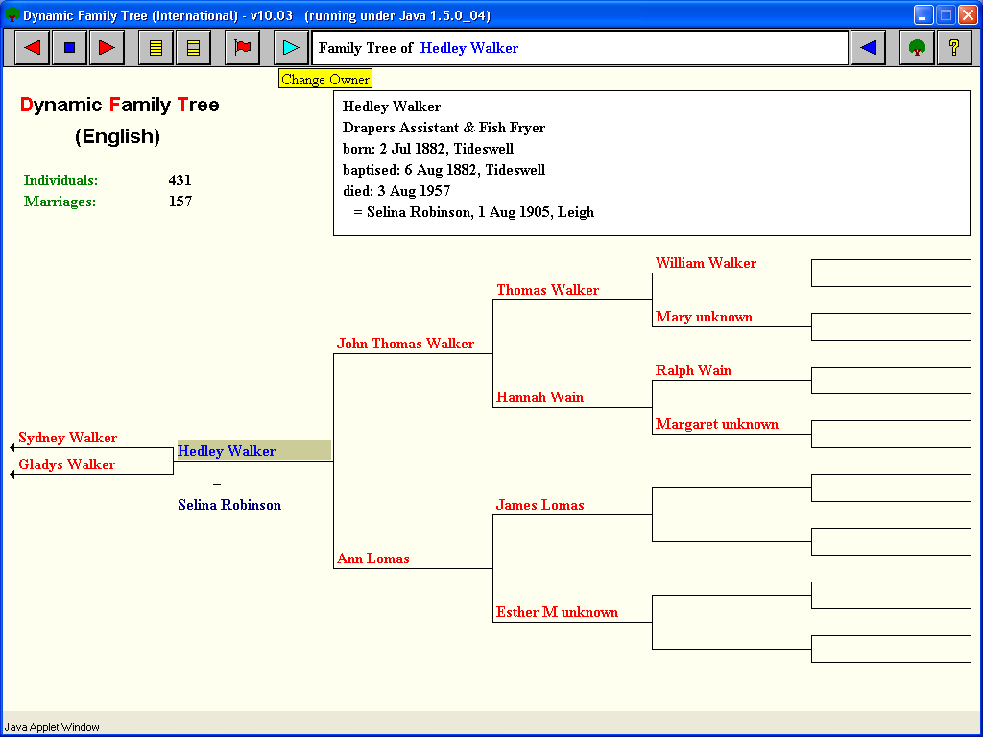
Click on anyone in the tree for them to become the focus. E.G. Selina Robinson.

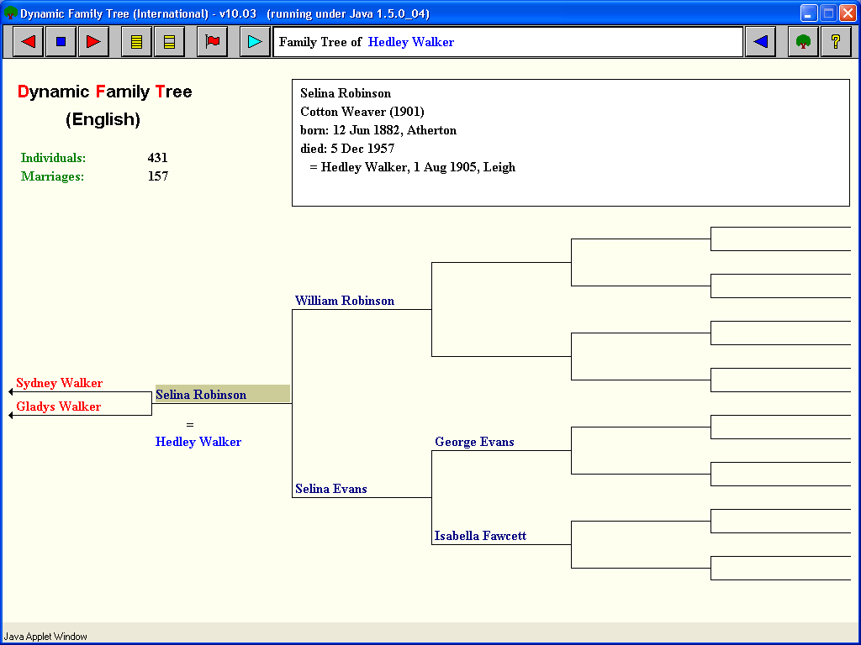
Any Questions?

Click the Yellow Help icon - ?

